**NBA API Stats Table of Contents**

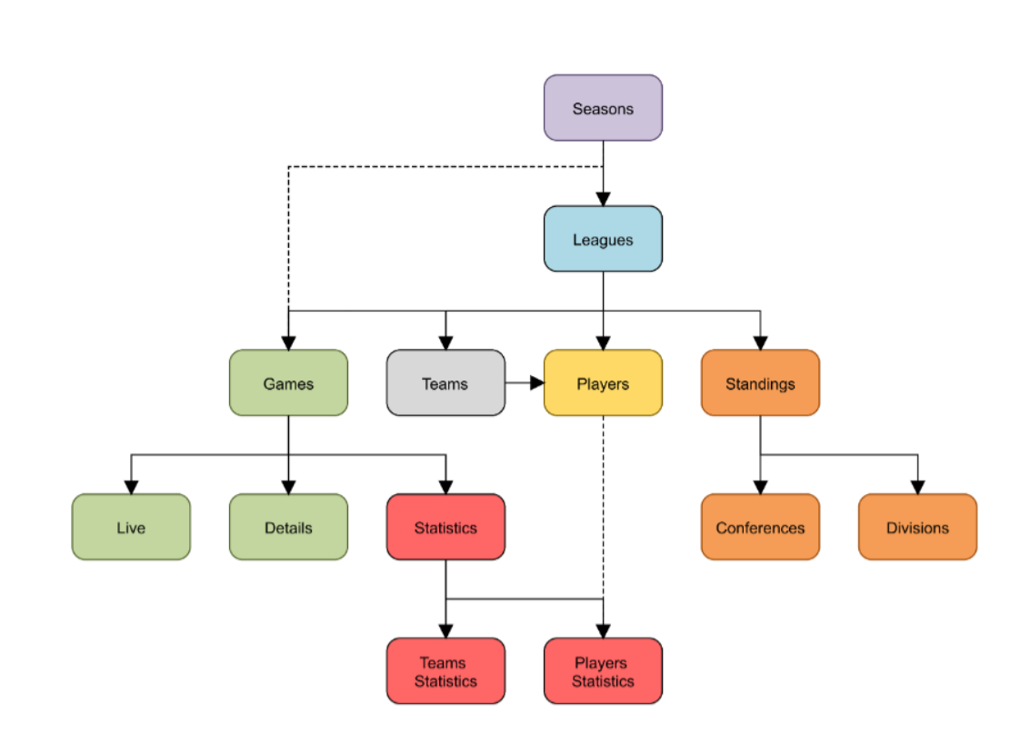

**from nba_api.stats.endpoints import playercareerstats**

|  |  |  |  |
| --- | --- | --- | --- |
| **title** | **details** | **useful?** | **Example: namehere.NameHere()** |
| **Player Career Stats** | Returns player stats by year. Must pass the player number. | Yes.  Has all game stats by year. | playercareerstats.PlayerCareerStats(player_id='203076') |
| **Draft History** | Draft history up to 2019. | Yes | drafthistory.DraftHistory() |
| **Get_Players** | List all players recorded | Yes | players.get_players() |
| **Draft Combine Drill Results** | Draft Combine drill results | Yes | draftcombinedrillresults.DraftCombineDrillResults() |
| **Draft Combine Stats** | Draft combine stats | No. only 2019. | draftcombinestats.DraftCombineStats() |
| **Player Dashboard By Team Performance** | Player Dashboard By Team Performance | No. Only 2019. | player_dashboard_by_team_performance |
| **Player Awards** | Player Awards | Yes. Awards show growth. | playerawards |
| **League Leaders** | League leaders . One year | No. 2019 only | leagueleaders.LeagueLeaders() |
| **Common player info** | common_player_info | Yes. Can select single player and get basic details | commonplayerinfo.CommonPlayerInfo(player_id='203076') |
| **Common all players** | commonallplayers | Yes. Can select all player and get basic details | commonallplayers.CommonAllPlayers() |
| **League dash player stats** | League dash player stats | Maybe. Has one year of current player basic stats | leaguedashplayerbiostats.LeagueDashPlayerBioStats() |
|  |  |  |  |
|  |  |  |  |
|  |  |  |  |
|  |  |  |  |

References :

<https://www.kaggle.com/rikdifos/nba-players-salary-prediction>

https://www.kaggle.com/noahgift/nba-player-power-influence-and-performance